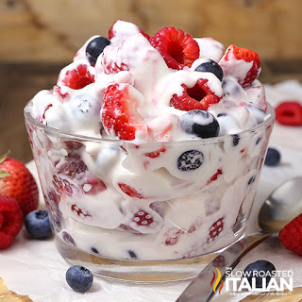
Berry Cheesecake Salad
Prep time/Total time 15 min
8 Servings
Ingredients
1 lb strawberries
9 oz blueberries
9 oz raspberries
8 oz cream cheese
½ cup French vanilla coffee creamer
Directions
- Wash all berries. Hull and cut strawberries into slices. Remove stems from blueberries. Lay on paper towels to dry.
- Microwave cream cheese for 20 seconds to soften.
- In a medium tall bowl, using an electric mixer, whip cream cheese until it becomes smooth. It may bind up in the beaters but continue as is and it will loosen up.
- With the mixer running slowly, add creamer to the cream cheese approximately a tablespoon at a time (otherwise it will become lumpy). Mix until it becomes a smooth mixture and all the creamer has combined into the cream cheese. Continue to whip until smooth, light and fluffy, about 2 minutes.
- Fold in berries to the cheesecake mixture until completely combined.
- Serve immediately or chill until ready to serve.

Notes
To make ahead of time, prepare cheesecake mixture and refrigerate in a bowl. Mix all the fruit in a large bowl and refrigerate. Before serving, drain any excess liquid from the fruit and then fold the cheesecake filling into the fruit.
You can substitute ½ cup heavy cream, 2 tablespoons of powdered sugar and 1 teaspoon of vanilla extract for creamer.

